# Introduction

The purpose of this test plan is to outline the testing approach for the website <https://buggy.justtestit.org/>. The website is an application that allows users to vote and rate their favourite car. The website will be tested for functional and usability.

## Scope of Testing

The testing will cover the following areas:

* Functionality of the website
* Usability of the website
* User interface of the website

The following **will NOT be** performed

* Security testing
* Compatibility to different platforms and browsers
* Performance of the website

## Test Objective

The objectives of the testing are to:

* Ensure that the website is functioning as expected
* Verify the usability of the website
* Bugs/issues are identified

## Test Scenarios

* Verify that the user can create a new account
* Verify that the user can log in with valid credentials
* Verify that the user can rate a car
* Verify that the user can comment on a car
* Verify that the user can view Popular Make
  + Verify sorting by Model works for both ASC and DESC
  + Verify sorting by Rank works for both ASC and DESC
  + Verify sorting by Votes works for both ASC and DESC
  + Verify user can expand View more option of comments
* Verify that the user can view Popular Model
* Verify that the user can view Overall Rating
  + Verify sorting by Make works for both ASC and DESC
  + Verify sorting by Model works for both ASC and DESC
  + Verify sorting by Rank works for both ASC and DESC
  + Verify sorting by Votes works for both ASC and DESC
  + Verify sorting by Engine works for both ASC and DESC
  + Verify user can expand View more option of comments
* Verify that user is able to update Profile
* Verify that user is able to log out

## Defects

**Home Page**

url: <https://buggy.justtestit.org/>

1. The textfield for username and password input is not properly labelled
   1. Textfield for username is labelled as login

Expectation – It’s appropriate to label it as “User name” instead of “Login”

* 1. Textfield for password has no label
     1. Expectation – the user should be given clear direction on where to enter login details

1. Incorrect label for the button that handles the functionality to log in the user
   1. Expectation – “login” is a noun, the label should be “Log In” which signifies an action

**Registration Page**

url: <https://buggy.justtestit.org/register>

1. The error prompt for not meeting the required password string is not user friendly

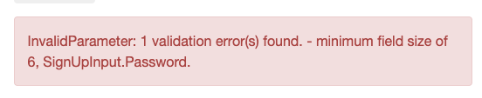

* 1. Expectation – The message prompt should say “The parameter does not meet the required input: 1) Minimum of 6 characters; 2) Must have a combination of uppercase and lowercase; 3) Must include special character; 4) Must have a number

1. Wrong message prompt for password that meets minimum length

**Steps**

1. On Login field enter “f”
2. On First Name field enter “f”
3. On Last Name field enter “f”
4. On Password field enter “Abc1234”
5. On Confirm Password field enter “Abc1234”

Expected result: The user should receive an error message that the input needs to include special characters

Actual result: Wrong error message displayed

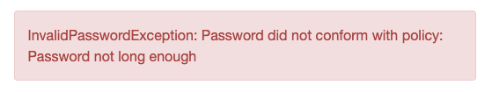

1. After successful user registration, the current page does not exit.

Expected result: The user should be redirected back to the Home page

1. The header Register button is interactable but non functional when in the Registration page



Expected result: The registration page should reload and clear all inputs from the registraiton field if the button is pressed or disable the button (currently the user is able to interact with the button)

**Profile Page**

url: <https://buggy.justtestit.org/profile>

1. Age textfield only prompts for int/float value not between 0 to 95. It is not consistent with other input input e.g. #100

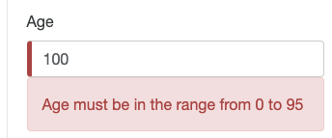

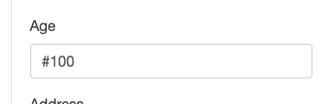

Expected result: The error prompt to the user should be consistent for any invalid input

1. Uncharacteristed error message “Get a candy ;)”

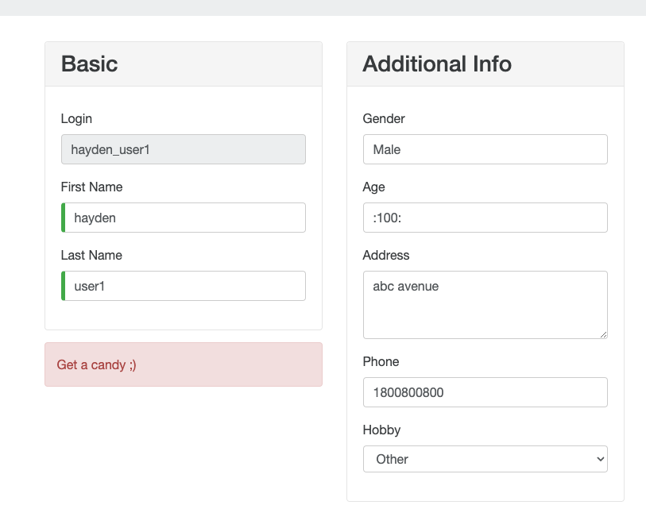

Expected result: The error message should clearly explain to the user what data entered is invalid

**Popular Make page**

url: <https://buggy.justtestit.org/make/c4u1mqnarscc72is00ng>

1. Hyperlink “Model” does nothing when the user interacts with it

Expect result: Clicking the link should performan an action (e.g. sorts the list asc > desc)

1. Hyperlink “Rank” does nothing when the user interacts with it

Expect result: Clicking the link should performan an action (e.g. sorts the list asc > desc)

1. Hyperlink “Votes” performs wrong sorting

Expected result: The list should be sorted from e.g highest to lowest or lowest to hightest votes

Actual result: Hyperlink interaction left out some of the listed cars from being sorted (partial sorting)

1. The Buggy Rating logon header is non-functional when interacted with in Popular Make page. The user will have no means to get back to the Home page

Expected result: When the user clicks on this header, it should allow the user to be redirected to the Home page.

Actual result: Buggy Rating header interaction is inconsistent on different pages of this website. In Popuplar Make page, the user will be stuck and won’t be able to go back to the Home page via website element interaction

**Popular Model page**

url: <https://buggy.justtestit.org/model/c4u1mqnarscc72is00ng%7Cc4u1mqnarscc72is00sg>

1. The Author column is empty

Expected result: The column should list the name of the user that post the comment

**Overall Rating page**

url: <https://buggy.justtestit.org/overall>

1. The use is able to continuosly click on the “Next” button after max page to has been reached

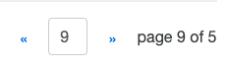

Expected resut: The Next button should be disabled when max page to display the list has been reached

1. The textfield that accepts page numbers does not restricted the user for invalid page input



Expected result: The user should be prompted that the page they’re trying to enter is invalid

1. Hyperlink to “Twitter” page is broken
2. Hyperlink “Rank” performs wrong sorting

Expected result: Sorting is wrong when user interacted with the “Rank” hyperlink



1. Entering value = “1” on page input field and pressing “Enter” key from keyboard does not work

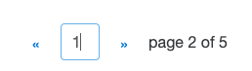

Expected result: The page should redirect to the first page

1. Hyperlink “Engine” sort only allows order from lowest to highest

Expected result: The user should be able to sort both ways

1. Logout button does not allow the user to log out in this page

*Prereqquisite*: User is already logged in

Expected result: The user should be able to successfully log out after it clicks the button